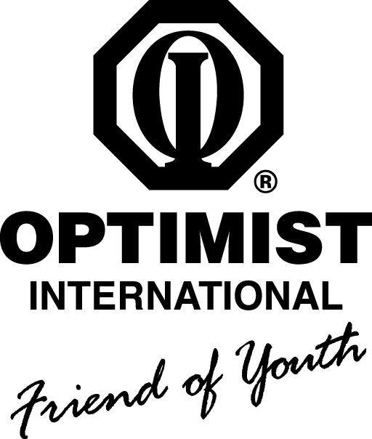

The Osborn Memorial Legacy Scholarship Application

The Oklahoma District of Optimist International created this $1000 scholarship to honor its esteemed members, Ron and Judy Osborn. It is our goal to award this scholarship to a student who is a child of a career firefighter.

APPLICATION DEADLINE IS FEBRUARY 28, 2019.
Emails must be received by midnight CST; US mail postmarked by then.

Applicant’s Name____________________________________________________________________________

Parent or Guardian__________________________________________________________________________

Fire Department ____________________________________________________________________________

Phone (______) _____________________Email___________________________________________________

Grade Point Average______________ ACT/SAT Score______________________________________

Intended Course of Study___________________________________________________________________

Why did you choose this Course of Study?________________________________________________

________________________________________________________________________________________________

________________________________________________________________________________________________

Please list jobs and/or volunteer work you have done in this field.

1. _____________________________________________________________________________________________

2. _____________________________________________________________________________________________

3. _____________________________________________________________________________________________

Why do you want or need this scholarship? ______________________________________________

________________________________________________________________________________________________

To what College, University, or Technical Schools have you applied?

1. ______________________________________________________________________ Accepted? Yes/No

2. ______________________________________________________________________ Accepted? Yes/No

3. ______________________________________________________________________ Accepted? Yes/No

Please list your activities, in order of their importance, indicating the amount of time during which you participated in each one.

1. ____________________________________________________________________ Time: ________________

2. ____________________________________________________________________ Time: ________________

3. ____________________________________________________________________ Time: ________________

4. ____________________________________________________________________ Time: ________________

Choose the one activity that you listed as most important and tell why the activity is significant. (Max 200 words.)

_________________________________________________________________________________________________

_________________________________________________________________________________________________

_________________________________________________________________________________________________

_________________________________________________________________________________________________

_________________________________________________________________________________________________

_________________________________________________________________________________________________

_________________________________________________________________________________________________

Please attach a letter of recommendation from a teacher, employer, or other non-related person. Their letter should include their contact information.

Interviews are possible; if so, we will contact you at the information you give us.

If you are a Tulsa Achieves recipient, this scholarship must be used for books and fees only.

Please return application to: pbthomasok@gmail.com
or
Legacy Scholarship
3106 East 87th Place
Tulsa, OK 74137

